SMOOTH START OF A SINGLE PHASE INDUCTION MOTOR

ABSTRACT
The project is designed to provide protection to induction motor, by applying voltage gradually from low to high for smooth start. Induction motor during the initial starting condition takes up much larger current than its capacity. This leads to motor instantly catching the speed resulting in high mechanical stress and also causing some damage to the motor windings. Sometimes the windings may also get burnt. Smooth start to the induction motor is based on the SCR firing angle control principle.
This project consists of a two anti-parallel SCR’s connected in series with an induction motor to the supply. At the time of start the firing angle is heavily delayed by received delayed pulses from an operational amplifier. The op-amp operates in comparator mode which compares zero voltage pulses to develop a saw-tooth voltage. This waveform is further compared against a varying voltage by charging and discharging of the capacitor to develop delayed pulses for triggering the SCRs. A lamp is provided in this project in place of an induction motor for demonstration purpose.
Further the project can be enhanced by using six SCRs, two connected in back to back for each phase.

BLOCK DIAGRAM

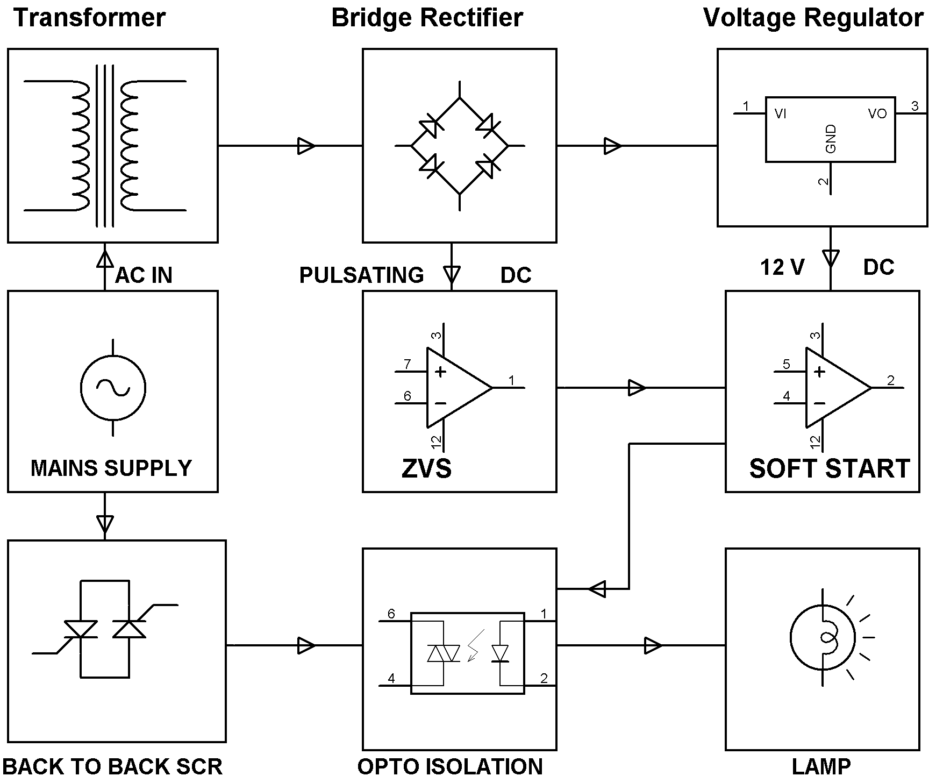
HARDWARE REQUIREMENTS:

Op-amp, Opto-isolators, SCRs, Voltage Regulator, Transformer, Diodes, LED, Resistors, Capacitors, Lamp.

